1. Set up the development enviroment:

* Android SKD:

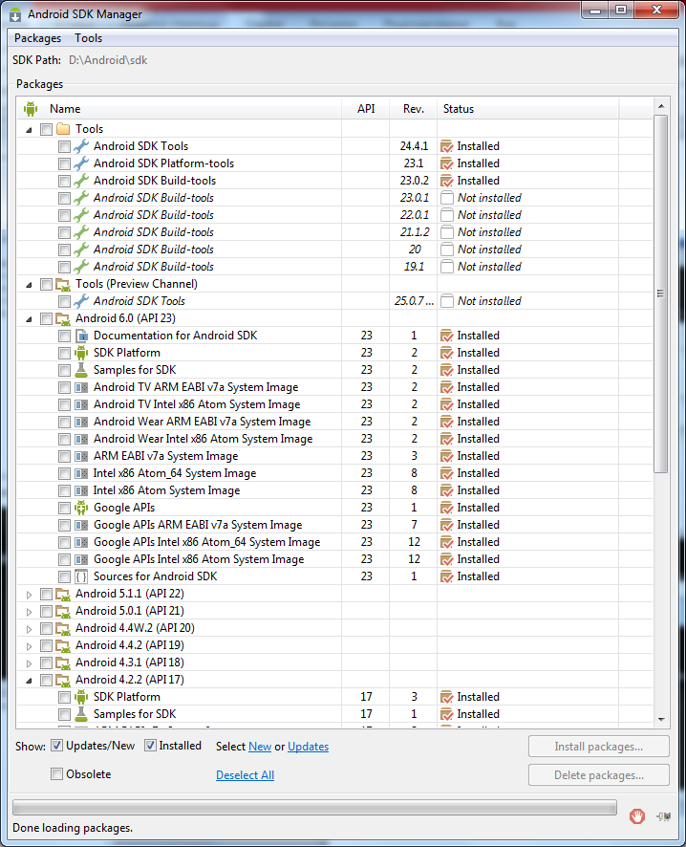

* Appium server

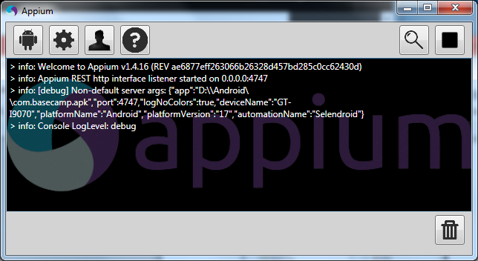

* Devices (emulator and physical device):

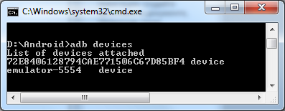

* Java

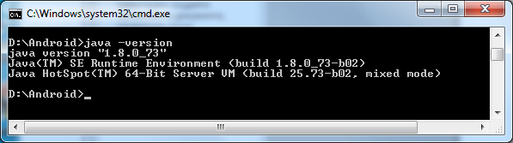

1. Execution

* UI Automator Viewer with connection to Emulator

